|  |  |
| --- | --- |
| **Sl. No** | **List of programs** |
|  | Design the following static web pages required for an online book store web site.   1. HOME PAGE: The static home page must contain three frames. 2. LOGIN PAGE 3. CATOLOGUE PAGE: The catalogue page should contain the details of all the books available. |
|  | Design a web page using CSS which includes the following:  i.Use different font and text styles  ii. Set a background image for both the page and single element on the page.  iii. Define styles for links  iv. Working with layers  v. Adding a Customized cursor |
|  | a) Develop and demonstrate the usage of inline, internal and external style sheet using CSS.  b) Write an HTML page that contains a selection box with a list of 5 countries. When the user selects a country, its capital should be printed next in the list. Add CSS to customize the properties of the font of the capital (color, bold and font size). |
|  | Write JavaScript to validate the following fields.   1. First Name (Name should contains alphabets and the length should not be less than 6 characters). 2. Password (Password should not be less than 6 characters length). |
|  | Write JavaScript to validate the following fields.   1. E-mail id (should not contain any invalid and must follow the standard pattern name@domain.com) 2. Mobile Number (Phone number should contain 10 digits) |
|  | Develop and demonstrate JavaScript with POP-UP boxes and functions for the following problems:   1. Input: Click on Display Date button using onclick( ) function Output: Display date in the textbox 2. Input: A number n obtained using prompt Output: Factorial of n number using alert |
|  | Develop and demonstrate JavaScript program for the following:  a)Input: A number n obtained using prompt Output: A multiplication table of numbers from 1 to 10 of n using alert  b) Input: A number n obtained using prompt and add another number using confirm Output: Sum of the entire n numbers using alert. |
|  | Write an HTML page including any required JavaScript that takes a number from text field in the range of 0 to 999 and shows it in words. It should not accept four and above digits, alphabets and special characters. |
|  | Write a program to build a clock using HTML, CSS And JavaScript. |
|  | Write a program to design a simple calculator using JavaScript. |
|  | Design an XML document to store information about a student in an engineering college affiliated to VTU. The information must include USN, Name, and Name of the College, Branch, Year of Joining, and email id. Make up sample data for 3students. Create a CSS style sheet and use it to display the document. |
|  | Create a application using Node.JS using MySQL. |

1. **Design the following static web pages required for an online book store web site**

**1) HOME PAGE: The static home page must contain three frames.**

**2) LOGIN PAGE**

**3) CATOLOGUE PAGE: The catalogue page should contain the details of all the books available.**

1) HOME PAGE: The static home page must contain three frames.

**Top frame**: Logo and the college name and links to Home page, Login page, Registration page, Catalogue page and Cart page (the description of these pages will be given below).

**Left frame** : At least four links for navigation, which will display the catalogue of respective links. For e.g.: When you click the link “CSE” the catalogue for CSE Books should be displayed in the Right frame.

**Right frame:** The pages to the links in the left frame must be loaded here. Initially this page contains description of the web site.

**index.html**  
<!DOCTYPE html>  
<html>  
<head>  
<meta charset="utf-8">  
<meta name="viewport" content="width=device-width, initial-scale=1">  
<title>Online Book Store</title>  
</head>  
<frameset rows="15%,10%,*">  
<frameset cols="20%,*">  
<frame name="f11" src="logo.html" scrolling="no"></frame>  
<frame name="f12" src="title.html" scrolling="no"></frame>  
</frameset>  
<frameset cols="20%,20%,20%,20%,*">  
<frame name="f21" src="home.html"></frame>  
<frame name="f22" src="login.html"></frame>  
<frame name="f23" src="reg.html"></frame>  
<frame name="f24" src="cat.html"></frame>  
<frame name="f25" src="cart.html"></frame>  
</frameset>  
<frameset cols="20%,*">  
<frame name="f31" src="branches.html"></frame>  
<frame name="f32" src="homepage.html"></frame>  
</frameset>  
</frameset>  
</html>

output:

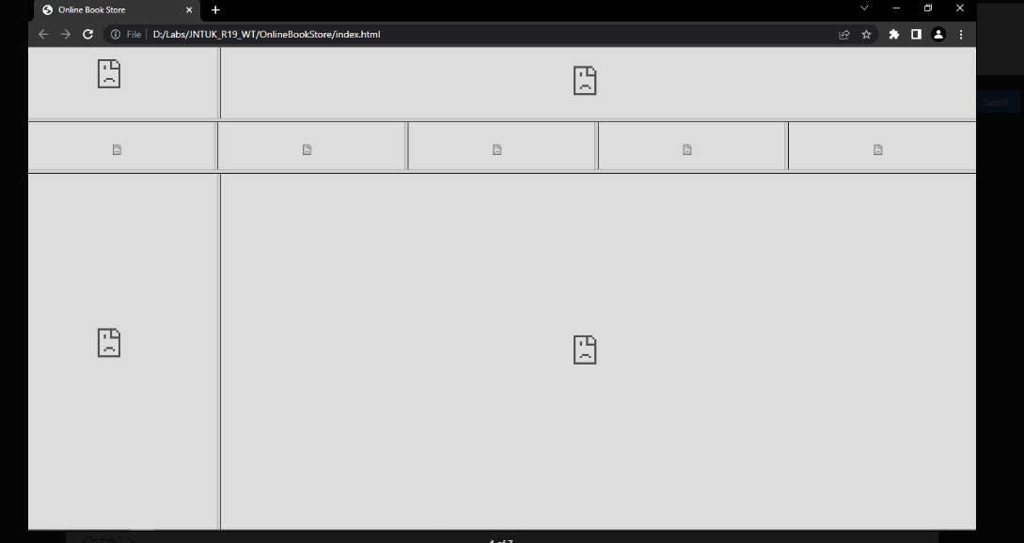

**home.html**  
<!DOCTYPE html>  
<html>  
<head>  
<meta charset="utf-8">  
<meta name="viewport" content="width=device-width, initial-scale=1">  
<title></title>  
</head>  
<body>  
<a href="homepage.html" target="f32">Home</a>  
</body>  
</html>

**login.html**  
<!DOCTYPE html>  
<html>  
<head>  
<meta charset="utf-8">  
<meta name="viewport" content="width=device-width, initial-scale=1">  
<title></title>  
</head>  
<body>  
<a href="loginpage.html" target="f32">Login</a>  
</body>  
</html>

**homepage.html**  
<!DOCTYPE html>  
<html>  
<head>  
<meta charset="utf-8">  
<meta name="viewport" content="width=device-width, initial-scale=1">  
<title></title>  
</head>  
<body>  
<p align="justify">Welcome to Online Book Store.<br>Here you find all types of books, magazines and national and international journals.</p>  
</body>  
</html>

out put :

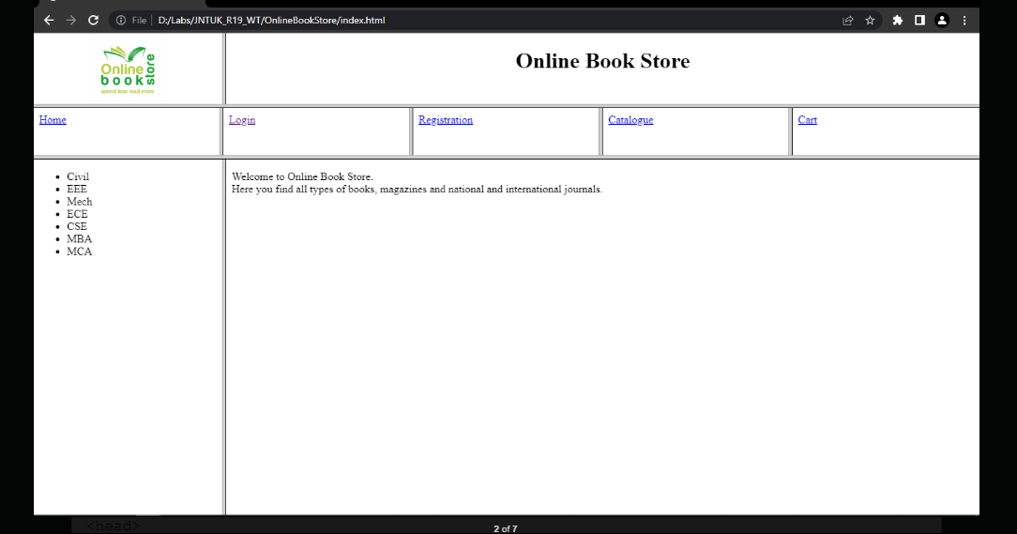

**loginpage.html**  
<!DOCTYPE html>  
<html>  
<head>  
<meta charset="utf-8">  
<meta name="viewport" content="width=device-width, initial-scale=1">  
<title></title>  
</head>  
<body>  
<form>  
<table align="center" cellspacing="15px">  
<tr>  
<td><b>Login</b></td>  
<td><input type="text" name="uname" /></td>  
</tr>  
<tr>  
<td><b>Password</b></td>  
<td><input type="password" name="upwd" /></td>  
</tr>  
<tr>  
<td colspan="2" align="center">  
<input type="submit" />&nbsp; &nbsp;  
<input type="reset" />  
</td>  
</tr>  
</table>  
</form>  
</body>  
</html

Output:

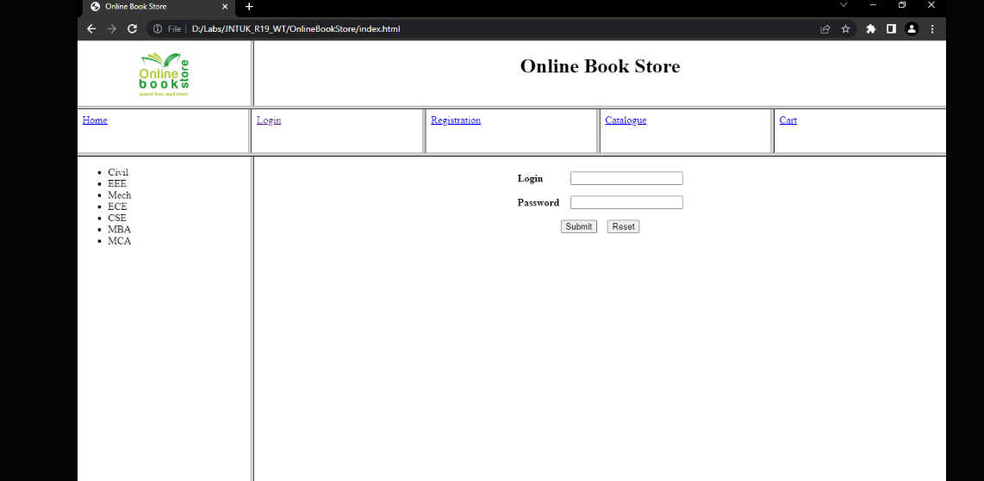

**cat.html**  
<!DOCTYPE html>  
<html>  
<head>  
<meta charset="utf-8">  
<meta name="viewport" content="width=device-width, initial-scale=1">  
<title></title>  
</head>  
<body>  
<a href="catpage.html" target="f32">Catalogue</a>  
</body>  
</html>

**catpage.html**  
<!DOCTYPE html>  
<html>  
<head>  
<meta charset="utf-8">  
<meta name="viewport" content="width=device-width, initial-scale=1">  
</head>  
<body>  
<form>  
<table cellspacing="10">  
<tr>  
<td><img src="images/html5.jpg" width="100" height="100"></td>  
<td> Title : HTML5 and CSS3 <br>  
Author : Sasha Vodnik&nbsp; &nbsp;<br> </td>  
<td>Rs. 700 /- </td>  
<td><input type="image" src="images/addToCart.jpg" width="150" height="70"></td>  
</tr>  
<tr>  
<td><img src="images/php.jpg" width="100" height="100"></td>  
<td> Title : PHP and MYSQL <br>  
Author : W. Jason Gilmore&nbsp; &nbsp;<br> </td>  
<td>Rs. 650 /- </td>  
<td><input type="image" src="images/addToCart.jpg" width="150" height="70"></td>  
</tr>  
<tr>  
<td><img src="images/j2ee.jpg" width="100" height="100"></td>  
<td> Title : The Complete Reference JAVA 2 <br>  
Author : Herbert Schildt &nbsp; &nbsp;<br> </td>  
<td>Rs. 850 /- </td>  
<td><input type="image" src="images/addToCart.jpg" width="150" height="70"></td>  
</tr>  
</table>  
</form>  
</body>  
</html>

out put:

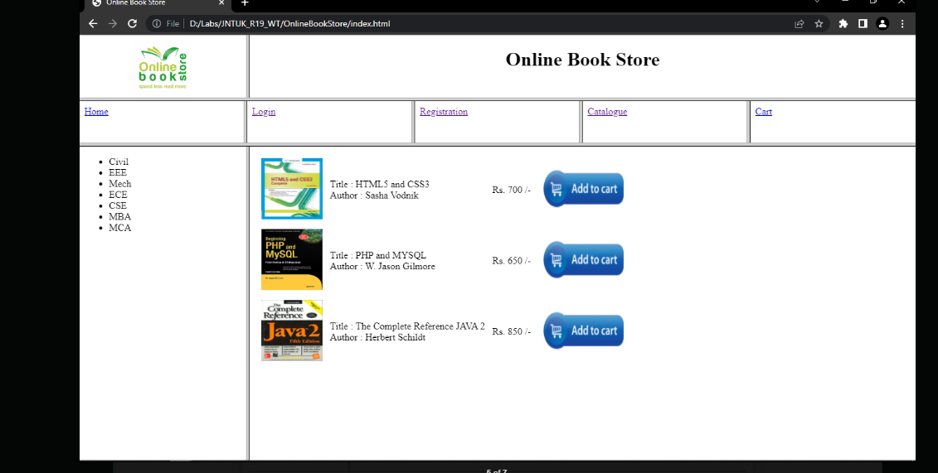

**2. Design a web page using CSS which includes the following:**

**i. Use different font and text styles**

**ii. Set a background image for both the page and single element on the page.**

**iii. Define styles for links**

**iv. Working with layers**

**v. Adding a Customized cursor**

1) Use different font, styles: In the style definition you define how each selector should work (font, color etc.). Then, in the body of your pages, you refer to these selectors to activate the styles.

**1) Use different font, styles**:

<html>

<head>

<style type="text/css">

.xlink{cursor:crosshair}

.hlink{cursor:help} b.headline

{

color:red;

font-size:24px; font-family:arial;

text-decoration:underline;

}

</style>

</head>

<body>

<b><a href="mypage.html" class="xlink"> crosslink</a><br>

<a href="mypage.html" class="hlink">helplink</a><br></b>

<b class="headline">this is heading style bold</b>

</body>

</html>

**2.Set a background image**

<html>

<head>

<style type="text/css">

body

{

background-image:url(logo.jpg);

}

.paragraph

{

background-image:url(logo.jpg);

}

</style>

</head>

<body>

<p>Gudlavalleru Engineering College</p>

</body></html>

**3. Control the repetition of the image with the background-repeat property.**

<html>

<head>

<style type="text/css"> body

{

background-image:url(logo.jpg); background-repeat:no-repeat;

}

.pragraph

{

background-image:url(logo.jpg);

}

</style>

</head>

<body>

<p> MITS, madanapalle</p>

</body>

</html>

**4.Define styles for links**

<html>

<head>

<style type="text/css"> A:link

{

color:black;

text-decoration:none;

}

A:visited

{

color:black;

text-decoration:none;

}

A:hover

{

color:red;

text-decoration:underline;

}

A:active

{

color:red;

text-decoration:underline;

}

</style>

</head>

<body>

<a href="cse.html">cse</a>

<br>

<a href="it.html">it</a><br>

<a href="ece.html">ece</a><br>

<a href="me.html">me</a><br>

</body>

</html>

**5.Work with layers**

<html>

<head>

<body>

<strong>LAYER1 ON TOP</strong>

<div style="position:relative; font-size:30px;

z-index:2; color:orange"> TOPLAYER</div>

<div style="position:relative; font-size:30px;top:-50px;left:10px; z-index:1:color:orange">BOTTOMLAYER</div>

<strong> layer2 on top</strong>

<div style="position:relative; font-size:30px;

z-index:3">TOPLAYER</div>

<div style="position:relative; font-size:30px;

top:-50px; left:10px;

z-index:4"> BOTTOMLAYER</div>

</body>

</html>

**6.Add a customized cursor**

<html>

<head>

<style type="text/css">

.xlink{cursor:crosshair}

.hlink{cursor:help}

</style>

</head>

<body>

<b><a href="homepage.html"class="xlink">CROSSLINK</a><br>

<a href="homepage.html"class="hlink">HELPLINK</a><br>

</b>

</body>

</html>

**3. a) Develop and demonstrate the usage of inline, internal and external**

**Style sheet using CSS.**

**inline**

<!DOCTYPE html>

<html>

<head>

<title>In-line CSS Style</title>

</head>

<body>

<p style="color:purple; margin-left:20px">This is a first paragraph.</p>

<div style="color:purple; font-size:16px; background-color:#FF6633;">This is a second paragraph.</div>

</body>

</html>

**Internal**

**<!DOCTYPE html>**

**<html>**

**<head>**

**<title>Internal CSS Style</title>**

**<style type="text/css">**

**p {**

**color:purple;**

**margin-left:20px;**

**}**

**div{**

**color:purple;**

**font-size:16px;**

**background-color:#FF6633;**

**}**

**</style>**

**</head>**

**<body>**

**<p>This is a first paragraph.</p>**

**<div>This is a second paragraph.</div>**

**</body>**

**</html>**

**External**

1. Create a new .css file with the text editor, and add the style rules. For example:

.xleftcol {

float: left;

width: 33%;

background:#809900;

}

.xmiddlecol {

float: left;

width: 34%;

background:#eff2df;

}

1. In the <head> section of your HTML sheet, add a reference to your external .css file right after <title> tag:

<link rel="stylesheet" type="text/css" href="style.css" />

/*CSS Style*/

p {

color:purple;

margin-left:20px;

}

div{

color:purple;

font-size:16px;

background-color:#FF6633;

}

<!DOCTYPE html>

<html>

<head>

<title>External CSS Style</title>

<link rel="stylesheet" type="text/css" href="style.css" />

</head>

<body>

<p>This is a first paragraph.</p>

<div>This is a second paragraph.</div>

</body>

</html>

**3 b) Write an HTML page that contains a selection box with a list of 5**

**Countries. When the user selects a country, its capital should be printed**

**Next in the list. Add CSS to customize the properties of the font of the**

**Capital (color, bold and font size).**

<html>

<head>

<title>WT Lab manual program no. 5</title>

</head>

<style>

h1

{

color: red;

text-align: center;

}

.textbox1

{

color: blue;

font-size: 30px;

font-weight: bold;

}

</style>

<body>

<center>

<h1> Select the country name to find its capital</h1>

<form name="myform">

Select Country <select name="country" id="sbox1" onClick="myFunction()" required>

<option value=""></option>

<option value="NEW DELHI">INDIA</option>

<option value="CANBERRA">AUSTRALIA</option>

<option value="WASHINGTON D.C">AMERICA</option>

<option value="LONDON">UNITEDKINGDOM</option>

<option value="BERLIN">GERMANY</option>

</select><br><br>

Capital <input type="text" class="textbox1" id="sbox2">

</form>

</center>

<script>

function myFunction()

{ var a=document.getElementById("sbox1").value;

document.getElementById("sbox2").value=a;

}

</script> </body> </html>

**Output:**



**4. Write JavaScript to validate the following fields of the Registration page.**

1. **First Name (Name should contains alphabets and the length should not be less than 6 characters).**
2. **namevalidation.html**
3. <html>
4. <head>
5. <title>validating a textbox</title>
6. <script language="javascript">
7. function button_click()
8. {
9. var fname=f.fname.value;
10. var spchar = "!@#$%^&*()+=-[]\\\';,./{}|\":<>?~";
11. var number="0123456789";
12. if(fname.length<6)
13. {
14. alert("first name atleast 6 characters");
15. }
16. if(fname!="")
17. {
18. for (var i=0;i<fname.length;i++)
19. {
20. if(spchar.indexOf(fname.charAt(i)) != -1)
21. {
22. alert ("Userid should not have special characters");
23. f.fname.value=" ";
24. return false;
25. }
26. }
27. }
28. if(fname!="")
29. {
30. for (var i=0;i<fname.length;i++)
31. {
32. if(number.indexOf(fname.charAt(i)) != -1)
33. {
34. alert ("Userid should not have numbers");
35. f.fname.value="";
36. return false;
37. }
38. }
39. if(fname.length>=6)
40. alert("valid username");
41. }
42. }
43. </script>
44. <body>
45. <center>
46. <form name="f">
47. <table>
48. <h2 align="center">USER NAME VALIDATION</h2>
49. <tr>
50. <td align="right">USERNAME:</td>
51. <td><input type="text" name="fname" maxlength=20 size=30></td>
52. </tr>
53. <br>
54. <tr>
55. <td></td>
56. <td><input type="button" value="SUBMIT" onClick="button_click()"></td></tr>
57. </form>
58. </table>
59. </center>
60. </body>
61. </html>

Output:



1. **Password (Password should not be less than 6 characters length).**

<html>

<head>

<title>PASSWORD VALIDATION</title>

<script language="javascript">

function pass()

{

var pw=f.pw.value;

var cpw=f.cpw.value;

if(pw.length<6)

{

alert("PASSWORD MUST BE 6 CHARACTERS");

}

if(pw!=cpw)

{

alert("PASSWORD DON'T MATCH");

}

else if(pw.length>=6)

alert("PASSWORD VALIDATION SUCCESS");

}

</script>

</head>

<body>

<form name="f">

<table align="center">

<h2 align="center">PASSWORD VALIDATION</h2>

<br>

<tr>

<td align="right">PassWord:</td>

<td align="left"><input type="PassWord" maxlength="10" size="30"name="pw"></td>

</tr>

<tr>

<td align="right">Confirm PassWord:</td>

<td align="left"><input type="PassWord" maxlength="10" size="30"name="cpw"></td>

</tr>

<tr>

<td></td>

<td><input type="button" value="SUBMIT" onClick="pass()"/></td>

</tr>

</table> </form> </body> </html>

**Output:**

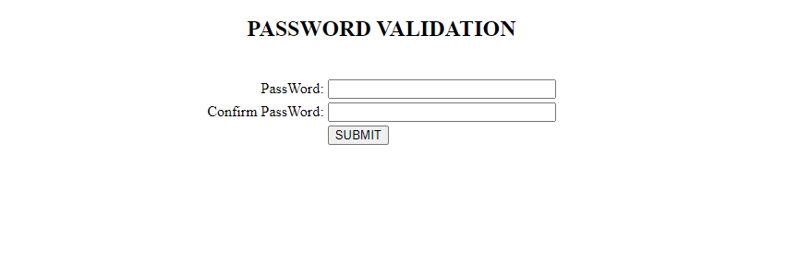

**5. Write JavaScript to validate the following fields.**

1. **E-mail id (should not contain any invalid and must follow the standard pattern** [**name@domain.com**](mailto:name@domain.com)**)**

<html>

<body>

<script>

function validateemail()

{

var x=document.myform.email.value;

var atposition=x.indexOf("@");

var dotposition=x.lastIndexOf(".");

if (atposition<1 || dotposition<atposition+2 || dotposition+2>=x.length){

alert("Please enter a valid e-mail address \n atpostion:"+atposition+"\n dotposition:"+dotposition);

return false;

}

}

</script>

<body>

<form name="myform" method="post" action="http://www.javatpoint.com/javascriptpages/valid.jsp" onsubmit="return validateemail();">

<table align="center">

<br><br><br><br>

<h2 align="center">Email Validation</h2>

<br>

<tr>

<td align="right">Email:</td>

<td align="left"><input type="text" maxlength="50" size="30"name="email"></td>

</tr>

<tr>

<td></td>

<td><input type="submit" value="Submit" onClick="validateemail()"/></td>

</tr>

</table> </form> </body> </html>

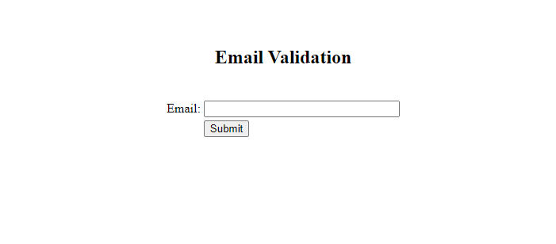

1. **Mobile Number (Phone number should contain 10 digits)**

<html>

<head>

<title>PHONE NUMBER VALIDATION</title>

<script language="javascript">

function phno()

{

var ph=f.ph.value;

if(ph.length==10)

{

if(isNaN(ph))

alert("It is not a valid Phone number");

else

alert("It is a valid Phone number");

}

else

alert("Please enter a valid phone number");

}

</script>

</head>

<body>

<form name="f">

<table align="center">

<br><br><br><br>

<h2 align="center">PHONE NUMBER VALIDATION</h2>

<br>

<tr>

<td align="right">PHONE NO:</td>

<td align="left"><input type="text" maxlength="15" size="30"name="ph"></td>

</tr>

<tr>

<td></td>

<td><input type="button" value="SUBMIT" onClick="phno()"/></td>

</tr>

</table> </form> </body> </html>

Output:

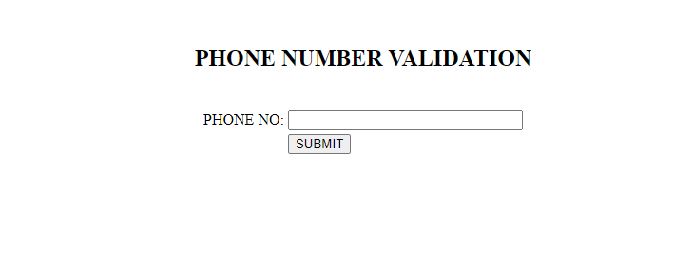

**6. Develop and demonstrate JavaScript with POP-UP boxes and functions for the following problems:**

1. **Input: Click on Display Date button using onclick( ) function Output: Display date in the textbox**

<html>

<body>

<script>

function display(){

var x="You have clicked";

var d=new Date();

var date=d.getDate();

var month=d.getMonth();

month++;

var year=d.getFullYear();

document.getElementById("dis").value=date+"/"+month+"/"+year;

}

</script>

<form>

<input type="text" id="dis" /><br />

<input type="button" value="Display Date" onclick="display()" />

</form>

<body>

</html>

**Output:**

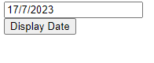

1. **Input: A number n obtained using prompt Output: Factorial of n**

<html>

<head>

<title>factorial</title>

<script language='javascript'>

function factorialcalc()

{

number = parseInt(prompt("enter a number, i'll calculate its factorial whole numbers bigger than zero, please"));

factorial = 1;

for (i=1; i <= number; i++)

{

factorial = factorial * i;

}

alert("the factorial of " + number + " is " + factorial);

}

</script>

</head>

<body align="center">

<form name=form>

<input type=button value="factorial" onclick="factorialcalc()">

</form>

</body>

</html>

Output:

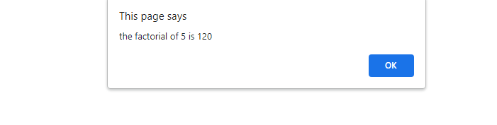

**7. Develop and demonstrate JavaScript program for the following:**

**a) Input: A number n obtained using prompt Output: A multiplication table of numbers from 1 to 10 of n using alert**

**<**html>

<head>

<title> Multiplication Table </title>

</head>

<body>

<script type="text/javascript">

var n=prompt("Enter positive value for n: ");

if(!isNaN(n)) {

var table="";

var number="";

for(i=1;i<=10;i++) {

number = n * i;

table += n + " * " + i + " = " + number + "\n";

}

alert(table);

}

else {

alert("Enter positive value");

n=prompt("Enter positive value for n: "," ");

}

document.write(n+" table values displayed using alert ..<br />");

</script>

</body>

</html>

Output:

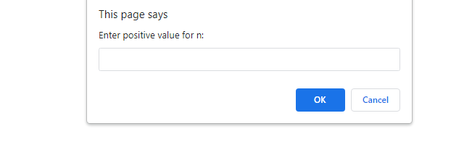

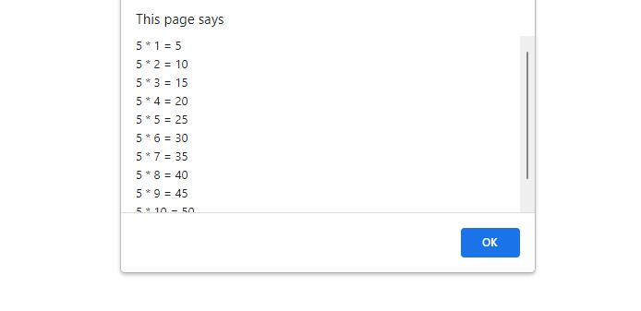

**b) Input: A number n obtained using prompt and add another number using confirm Output: Sum of the entire n numbers using alert.**

html>

<head>

<title> sum up the number </title>

</head>

<body>

<script type="text/javascript">

function sum()

{

var res=0;

var a=parseInt(prompt("enter the first number:"));

res=res+a;

while(confirm("add more number?"))

{

var c =parseInt(prompt("enter number:"));

res= res + c;

}

alert(" the sum of the number is :"+res);

}

sum();

</script>

</body>

</html>

Output:

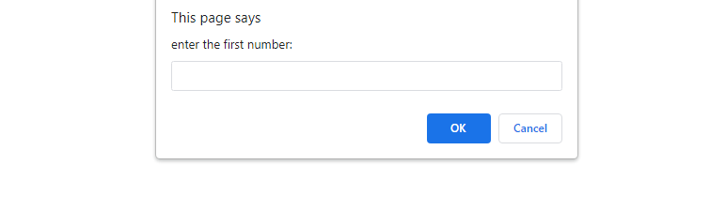

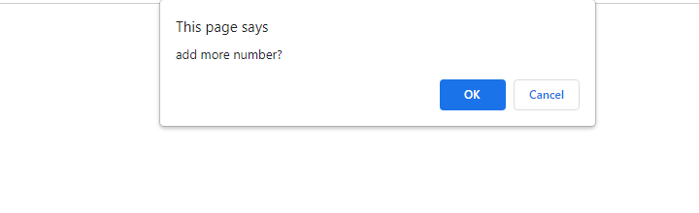



**8. Write an HTML page including any required JavaScript that takes a number from text field in the range of 0 to 999 and shows it in words. It should not accept four and above digits, alphabets and special characters.**

<html>

<head>

<title>Number in words</title>

<script language="javascript">

function convert()

{

var num=document.forms["frm1"].num.value;

document.forms["frm1"].words.value="";

if(isNaN(num))

{

alert("Not a Number");

}

else if (num<0 || num>999)

{

alert("Out of Range");

}

else

{

var len=num.length;

var words="";

for(var i=0;i<len;i++)

{

var n=num.substr(i,1); // the code extracts one character at a time from the num string in each iteration of the loop, starting from index i. This allows the code to process each digit of the entered number separately.//

switch(n)

{

case '0':words+="Zero ";break;

case '1':words+="One ";break;

case '2':words+="Two ";break;

case '3':words+="Three ";break;

case '4':words+="Four ";break;

case '5':words+="Five ";break;

case '6':words+="Six ";break;

case '7':words+="Seven ";break;

case '8':words+="Eight ";break;

default:words+="Nine ";

}

}

document.forms["frm1"].words.value=words;

}

}

</script>

</head>

<body>

<form name="frm1">

<center><h3>NUMBER IN WORDS</h3></center>

<br/>

<center>Enter a Number :<input type="text" name="num"</input><br/></center>

<br/>

<center><input type="button" name="inwords" value="In Words" onclick="convert()"></input></center>

<br/><br/><center>Number in Words :<input type="text" name="words"</input></center>

<br/>

</form>

</body>

</html>

**Output:**

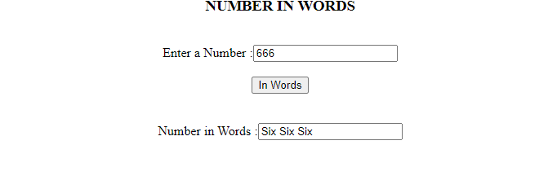

**9. Write a program to build a Clock using HTML, CSS and JavaScript.**

<html>

<head>

<title>Analog Clock Tutorials Point</title>

<style>

#sizeOfAnalog {

position: relative;

/*background: url(https://www.tutorialspoint.com/assets/questions/tmp/clock.png) no-repeat; */

background-size: 100%;

margin-top: 2%;

margin: auto;

height: 90vh;

width: 90vh;

}

#hour_clock {

position: absolute;

background: black;

border-radius: 10px;

transform-origin: bottom;

height: 25%;

top: 25%;

left: 48.85%;

opacity: 0.8;

width: 2%;

}

#minute_clock {

position: absolute;

background: black;

border-radius: 10px;

transform-origin: bottom;

left: 48.9%;

opacity: 0.8;

width: 1.6%;

height: 32%;

top: 18%;

}

#second_clock {

position: absolute;

background: black;

border-radius: 10px;

transform-origin: bottom;

width: 1%;

height: 36%;

top: 14%;

left: 50%;

opacity: 0.8;

}

</style>

</head>

<body>

<div id="sizeOfAnalog">

<div id="hour_clock"></div>

<div id="minute_clock"></div>

<div id="second_clock"></div>

</div>

<script>

var hour = document.getElementById("hour_clock");

var minute = document.getElementById("minute_clock");

var seconds = document.getElementById("second_clock");

var addClock = setInterval(function clock() {

var date_now = new Date();

var hr = date_now.getHours();

var min = date_now.getMinutes();

var sec = date_now.getSeconds();

var calc_hr = hr * 30 + min / 2;

var calc_min = min * 6;

var calc_sec = sec * 6;

hour.style.transform = "rotate(" + calc_hr + "deg)";

minute.style.transform = "rotate(" + calc_min + "deg)";

seconds.style.transform = "rotate(" + calc_sec + "deg)";

}, 1000);

</script>

</body>

</html>

Output:



**10. Write a program to design a simple calculator using JavaScript.**

**Calc.html**

<!-- Create a simple Program to build the Calculator in JavaScript using with HTML and CSS web languages. -->

<!DOCTYPE html>

<html lang = "en">

<head>

<title> JavaScript Calculator </title>

<style>

h1 {

text-align: center;

padding: 23px;

background-color: skyblue;

color: white;

}

#clear{

width: 270px;

border: 3px solid gray;

border-radius: 3px;

padding: 20px;

background-color: red;

}

.formstyle

{

width: 300px;

height: 530px;

margin: auto;

border: 3px solid skyblue;

border-radius: 5px;

padding: 20px;

}

input

{

width: 20px;

background-color: green;

color: white;

border: 3px solid gray;

border-radius: 5px;

padding: 26px;

margin: 5px;

font-size: 15px;

}

#calc{

width: 250px;

border: 5px solid black;

border-radius: 3px;

padding: 20px;

margin: auto;

}

</style>

</head>

<body>

<h1> Calculator Program in JavaScript </h1>

<div class= "formstyle">

<form name = "form1">

<!-- This input box shows the button pressed by the user in calculator. -->

<input id = "calc" type ="text" name = "answer"> <br> <br>

<!-- Display the calculator button on the screen. -->

<!-- onclick() function display the number prsses by the user. -->

<input type = "button" value = "1" onclick = "form1.answer.value += '1' ">

<input type = "button" value = "2" onclick = "form1.answer.value += '2' ">

<input type = "button" value = "3" onclick = "form1.answer.value += '3' ">

<input type = "button" value = "+" onclick = "form1.answer.value += '+' ">

<br> <br>

<input type = "button" value = "4" onclick = "form1.answer.value += '4' ">

<input type = "button" value = "5" onclick = "form1.answer.value += '5' ">

<input type = "button" value = "6" onclick = "form1.answer.value += '6' ">

<input type = "button" value = "-" onclick = "form1.answer.value += '-' ">

<br> <br>

<input type = "button" value = "7" onclick = "form1.answer.value += '7' ">

<input type = "button" value = "8" onclick = "form1.answer.value += '8' ">

<input type = "button" value = "9" onclick = "form1.answer.value += '9' ">

<input type = "button" value = "*" onclick = "form1.answer.value += '*' ">

<br> <br>

<input type = "button" value = "/" onclick = "form1.answer.value += '/' ">

<input type = "button" value = "0" onclick = "form1.answer.value += '0' ">

<input type = "button" value = "." onclick = "form1.answer.value += '.' ">

<!-- When we click on the '=' button, the onclick() shows the sum results on the calculator screen. -->

<input type = "button" value = "=" onclick = "form1.answer.value = eval(form1.answer.value) ">

<br>

<!-- Display the Cancel button and erase all data entered by the user. -->

<input type = "button" value = "Clear All" onclick = "form1.answer.value = ' ' " id= "clear" >

<br>

</form>

</div>

</body>

</html>

Output:

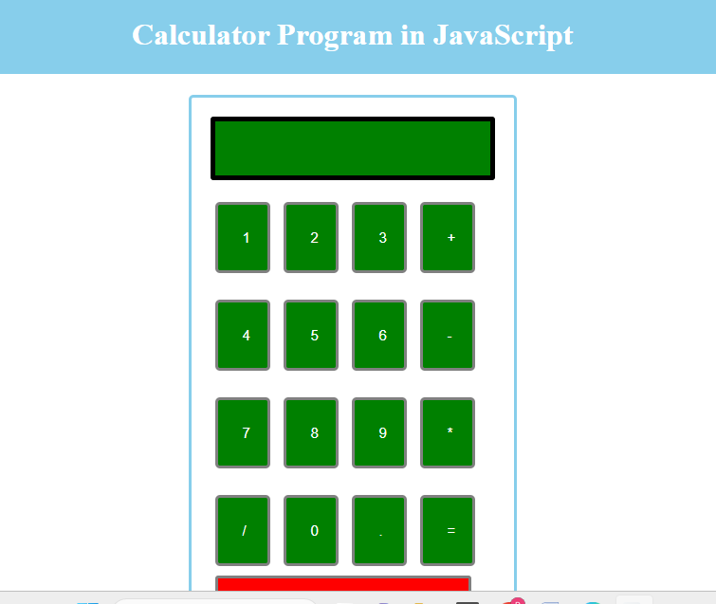

**11.** **Design an XML document to store information about a student in an engineering college affiliated to VTU. The information must include USN, Name, and Name of the College, Branch, Year of Joining, and email id. Make up sample data for 3students. Create a CSS style sheet and use it to display the document.**

<?xml-stylesheet type="text/css" href="5.css" ?>

<!DOCTYPE html>

<html>

<head>

<h1> STUDENTS DESCRIPTION </h1>

</head>

<students>

<student>

<USN>USN : 1JB01CS001</USN>

<name>NAME : CHETAN R</name>

<college>COLLEGE : RIT</college>

<branch>BRANCH : Computer Science and Engineering</branch>

<year>YEAR : 2005</year>

<e-mail>E-Mail : chetan@gmail.com</e-mail>

</student>

<student>

<USN>USN : 1JB01CS002</USN>

<name>NAME : AJAY</name>

<college>COLLEGE : RIT</college>

<branch>BRANCH : Information Science and Engineering</branch>

<year>YEAR : 2007</year>

<e-mail>E-Mail : ajay@gmail.com</e-mail>

</student>

<student>

<USN>USN : 1JB07EC001</USN>

<name>NAME : CHETAN</name>

<college>COLLEGE : SJBIT</college>

<branch>BRANCH : ECE</branch>

<year>YEAR : 2007</year>

<e-mail>E-Mail : chetan@gmail.com</e-mail>

</student>

</students>

</html>

**5.css**  
student{

display:block; margin-top:10px; color:Navy;

}

USN {

display:block; margin-left:10px;font-size:14pt; color:Red;

}

name {

display:block; margin-left:20px;font-size:14pt; color:Blue;

}

college{

display:block; margin-left:20px;font-size:12pt; color:Maroon;

}

branch{

display:block; margin-left:20px;font-size:12pt; color:Purple;

}

year {

display:block; margin-left:20px;font-size:14pt; color:Green;

}

e-mail {

display:block; margin-left:20px;font-size:12pt; color:Blue;

}

**12.** **Create a application using Node.JS using MySQL.**